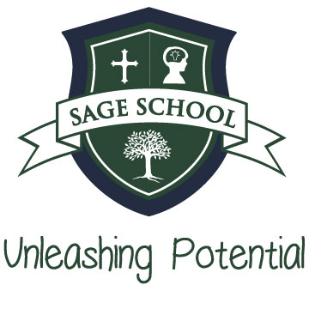
Sage School
2021-22 School Year Scholarship Application Form
Student Name:____________________________________________
Parent’s names: ___________________________________________
Address: ________________________________________________
Telephone numbers: ________________________________________
Email address: ____________________________________________
Student’s grade for the 2021-22 school year: ________________________
Please include the following items with your application:
  - A copy of parents’ income tax forms from the previous year submitted through https://factsmgt.com
(Social Security numbers will be removed before the scholarship packet is given to the committee)
  - Georgia State Bill 10 award letter with amount for current year, if applicable.
  - Parents, please write a letter explaining how this scholarship will benefit your family and how you plan to pay the remaining balance of your child’s tuition.

- Sage School partners with Apogee Scholarships to provide financial aid to qualified applicants. Please let the committee know if you meet any of the following criteria:

Beyond the internal requirements of Apogee's partner schools, scholarship applicants must also meet the following requirements as defined in HB 283:
- Eligible to enroll in a public Pre-K, Kindergarten, or 1st Grade or ...
- Coming from a public school to a private school for the first time or ...
- Coming from a home-school (1 year min) or charter school environment for the first time or ...
- Previously received an SSO Scholarship or ...
- Attended a minimum of 45 days of public school prior to enrolling at a qualified private school
- Has evidence of a documented case of bullying in the public school system
- Districted for a failing public school as defined by the Governor's Office of Student Achievement

Thank you for your application to Sage School’s Finance committee. The committee will review all packet information and reach back out to you within a week of receiving all documents. Our sincerest desire is to help as many students as possible receive the solid Orton-Gillingham education that Sage provides.
Please send completed application and letter to zach@chapkinaccounting.com
Sincerely,
Sage School/Finance Committee

